**CHAPTER 1**

**INTRODUCTION**

In today's rapidly evolving job market, organizations are increasingly relying on technology to streamline their hiring processes. However, traditional recruitment methods often suffer from inherent biases, whether conscious or unconscious, which can lead to unfair hiring practices. These biases may stem from various factors, including inconsistencies in evaluation criteria, subjective decision-making, or reliance on limited data points. Such biases undermine the effectiveness of recruitment strategies and prevent companies from selecting the best candidates based on merit.

To address this critical issue, organizations are turning to Artificial Intelligence (AI) and machine learning to bring fairness and transparency to recruitment. AI-driven hiring solutions can systematically analyze large datasets, recognize potential biases in decision-making, and ensure that recruitment decisions are data-driven and objective. Ethical AI tools provide employers with a powerful means to evaluate candidates fairly by detecting inconsistencies in assessments and ensuring a standardized selection process. By leveraging AI ethics, natural language processing (NLP), and fairness indicators, this project introduces an AI-powered Job Application Tracking System. The system is designed to create an unbiased hiring environment by incorporating ethical AI principles, soft skills assessment, and equitable candidate ranking mechanisms. Through this innovative approach, companies can improve hiring accuracy, enhance employee satisfaction, and maintain compliance with fair recruitment standards.

**1.1 The Need for Fair and Unbiased Hiring**

In the modern recruitment landscape, hiring decisions often suffer from unintended biases that result in unfair candidate evaluations. These biases may arise from inconsistencies in scoring criteria, human subjectivity, or reliance on limited data during the assessment process. As a result, talented candidates may be overlooked due to structural inefficiencies rather than merit. Therefore, there is an increasing need for a system that ensures fairness, transparency, and equal opportunity for all candidates based on performance-driven metrics rather than subjective impressions.

**1.2 Role of AI in Ethical Hiring**

Artificial Intelligence (AI) offers a powerful solution to the problem of biased recruitment by automating the hiring process and enabling the analysis of large datasets to identify patterns of unfair decision-making. AI-based fairness tools, such as TensorFlow Fairness Indicators and IBM’s AIF360, can detect and mitigate these biases in hiring decisions by ensuring that evaluation criteria are consistent and standardized across all candidates. The application of AI ethics in hiring has the potential to revolutionize recruitment by making it more merit-based, transparent, and data-driven.

**1.3 Key Features of the System**

This project presents an AI-powered Job Application Tracking System designed to promote fair and unbiased hiring. Built with ReactJS and Flask, the system integrates AI ethics tools and natural language processing (NLP) techniques to evaluate candidates impartially.

**1.3.1 Bias Detection Using AI Ethics Tools**

The system leverages advanced AI Ethics tools, such as TensorFlow Fairness Indicators and IBM AIF360, to identify and mitigate inconsistencies during the recruitment process. These fairness metrics ensure that hiring decisions are based on candidate qualifications, without any undue influence from flawed evaluation criteria, thus promoting a level playing field for all applicants.

**1.3.2 Soft Skills Analysis with NLP**

To enhance the evaluation process, the system also incorporates NLP models from Hugging Face to analyze candidates' activity descriptions for soft skills such as communication, teamwork, and leadership. By using AI to examine interpersonal skills, the system ensures a more holistic assessment of each candidate beyond technical expertise, allowing for a balanced consideration of qualifications.

**1.3.3 Candidate Scoring and Fair Ranking**

By integrating both fairness checks and soft skills insights, the system generates a balanced score for each candidate. This score is designed to be a more comprehensive reflection of a candidate's qualifications, ensuring that all factors—both technical and interpersonal—are weighed fairly. The final ranking produced by the system helps organizations make more data-driven, transparent, and unbiased hiring decisions.

# CHAPTER 2

**LITERATURE REVIEW**

## ABOUT THE PROJECT

## The AI-powered Job Application Tracking System is designed to mitigate biases in hiring and ensure fair and transparent recruitment processes. By incorporating AI-driven fairness metrics and natural language processing, the system evaluates candidates holistically, balancing technical skills with soft skills. The system uses ethical AI tools to eliminate biases and provide standardized candidate assessments. This ensures that hiring decisions are data-driven and equitable, improving workforce diversity and recruitment efficiency. The system further integrates advanced natural language processing models to analyze candidate responses, enabling a deeper understanding of their capabilities beyond just qualifications.

### LITERATURE REVIEW

#### [1] Fairness in AI-Based Hiring: A Review of Bias Mitigation Strategies

This study explores the challenges associated with AI-driven hiring systems, particularly the biases that arise due to imbalanced training data and algorithmic limitations. The authors highlight various bias mitigation techniques, including adversarial debiasing, re-weighting strategies, and fairness-aware learning frameworks. The research emphasizes that while AI can improve hiring processes, it is critical to continuously evaluate and refine fairness metrics to ensure ethical decision-making.

#### [2] AI in Recruitment: Enhancing Fairness and Efficiency

#### This paper discusses the role of AI in recruitment, focusing on automated resume screening, skill-based candidate ranking, and behavioral analysis. The study finds that AI can significantly reduce hiring bias when properly implemented but warns that reliance on historical data may perpetuate existing disparities. The research also highlights the importance of transparency in AI-based hiring systems and the need for organizations to adopt explainable AI models to justify hiring decisions.

#### [3] Soft Skills Analysis Using Natural Language Processing

The study examines how NLP techniques can be used to assess candidates' soft skills based on their textual responses. Using transformer-based models, the research demonstrates that AI can effectively analyze communication styles, leadership potential, and teamwork attributes. The findings support the integration of NLP in hiring systems to ensure a more comprehensive evaluation of candidates beyond their technical qualifications.

#### [4] Title: Fairness Indicators for AI-Powered Hiring Systems

This research presents an evaluation of fairness indicators, such as demographic parity, equal opportunity, and disparate impact, within AI-driven recruitment platforms. The authors propose a framework for assessing and mitigating biases in hiring algorithms, using real-world hiring datasets. The study concludes that AI fairness tools, such as TensorFlow Fairness Indicators and IBM AIF360, play a vital role in maintaining ethical recruitment practices.

**2.3 Existing Systems**

Current AI-driven hiring platforms mainly focus on resume screening and applicant tracking. These systems rely heavily on historical data for training, which often results in biases based on gender, race, or background. Some tools incorporate basic fairness checks, such as gender-neutral language, but these measures are often insufficient to mitigate deeper biases, especially regarding the candidate's diverse background or experiences.

Additionally, these platforms typically prioritize technical qualifications, neglecting essential soft skills like communication, leadership, and teamwork, which are crucial for overall job performance. Transparency is another challenge, as many systems operate as "black boxes," leaving recruiters unable to understand how decisions are made. This lack of clarity undermines trust in the system and makes it difficult to address potential biases.

**2.4 Proposed System**

The proposed AI-powered Job Application Tracking System aims to overcome these limitations by integrating fairness indicators, NLP-based soft skills analysis, and transparent AI models. Using tools like **TensorFlow Fairness Indicators** and **IBM AIF360**, the system ensures unbiased decision-making by assessing and mitigating bias throughout the recruitment process. This approach ensures that all candidates are evaluated based on their merit, irrespective of demographic factors.

Furthermore, the system employs **Natural Language Processing (NLP)** to analyze soft skills such as communication, leadership, and adaptability—skills often overlooked by traditional systems. By evaluating both technical and non-technical qualifications, the system offers a balanced scoring mechanism that provides a comprehensive evaluation of candidates.

Unlike traditional platforms, this system offers transparency in its decision-making process. Recruiters can access detailed insights into how rankings and recommendations are made, promoting trust and accountability. By combining fairness, NLP, and transparency, the system addresses the biases present in current hiring systems, improving recruitment outcomes and ensuring a more equitable selection process.

# CHAPTER 3

# SYSTEM REQUIREMENTS

#### Hardware Requirements

* **Processor:** Minimum Intel Core i3 / Recommended Intel Core i5 or AMD Ryzen
* **RAM:** Minimum 4 GB / Recommended 8 GB+
* **Storage:** At least 5 GB of free space
* **Display:** Minimum 1366x768 resolution / Recommended Full HD
* **Internet:** Required for cloud-based AI tools and APIs

### Software Requirements

* **Operating System:** Windows 10/11, macOS, or Linux (Ubuntu 20.04+)
* **Programming Languages:** Python 3.8+
* **Frontend:** ReactJS, Redux
* **Backend:** Flask, MySQL
* **AI/ML Libraries:** TensorFlow Fairness Indicators, IBM AIF360, Hugging Face Transformers
* **Code Editor:** VS Code

# CHAPTER 4

**SYSTEM ARCHITECTURE**

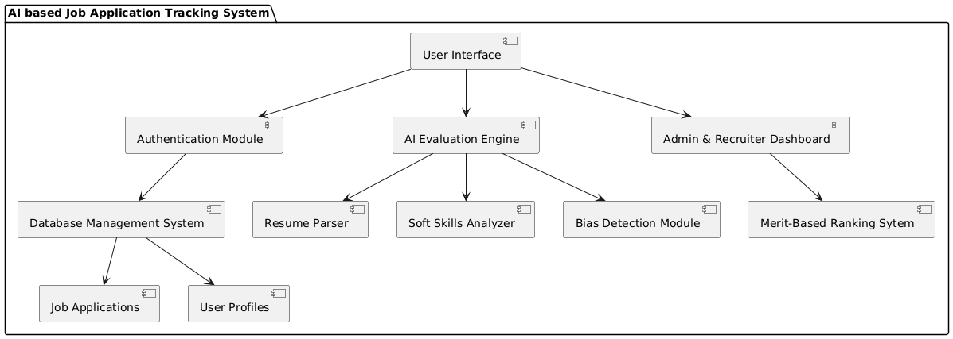

Fig 4.1: System Architecture

The AI-powered Job Application Tracking System follows a modular architecture to ensure an unbiased and efficient hiring process. The system consists of several key components that work together to analyze applications, rank candidates fairly, and provide insights to recruiters.

The **User Interface (UI)** serves as the primary access point for applicants and recruiters. Applicants can submit their resumes and job applications through the web application, while recruiters can access dashboards to evaluate candidates. The UI interacts with the **Authentication Module**, which manages user roles (Admin, Recruiter, Applicant) and ensures secure access control.

The **AI Evaluation Engine** is at the core of the system. It processes job applications using a **Resume Parser**, which extracts relevant details such as education, work experience, and skills. The **Soft Skills Analyzer**, powered by NLP algorithms, evaluates an applicant’s soft skills based on their resume content and responses. The **Bias Detection Module** ensures fairness by identifying and mitigating potential biases in the evaluation process.

The **Database Management System (DBMS)** stores all relevant data, including user profiles, job listings, and AI-generated evaluation scores. This structured storage allows efficient data retrieval and analysis.

The **Ranking and Recommendation System** ranks applicants based on a **Merit-Based Ranking Algorithm**, which uses predefined criteria such as skills, experience, and soft skill assessments. The **AI Recommendation Engine** suggests the best candidates for each job role while ensuring diversity and fairness in selections.

The system integrates with **External APIs and Services** such as NLP models for advanced text analysis, cloud storage for document management, and email notifications to keep applicants updated on their application status.

Finally, the **Admin & Recruiter Dashboard** provides a centralized view of candidate applications, ranking results, and system analytics. Recruiters can use this interface to filter candidates, review AI-generated scores, and make data-driven hiring decisions.

By leveraging AI-driven evaluation mechanisms and fairness indicators, this system enhances the efficiency and objectivity of recruitment processes, ensuring that candidates are assessed solely based on merit and relevant qualifications.

# CHAPTER 5 UML DIAGRAMS

## INTRODUCTION TO UML

The Unified Modelling Language (UML) offers software engineers a standardized approach to visually represent an analysis model, governed by a set of rules that ensure proper syntax, semantics, and practicality. A UML system is visualized through unique views, each highlighting a different aspect of the system. These views are outlined as follows

### User Model View

* Focuses on the system from the user's standpoint.
* Describes usage scenarios to showcase how end-users interact with the system.

### Structural Model View

* Highlights the static framework of the system.
* Represents internal data and functionality, emphasizing relationships and dependencies among components such as classes and objects.

### Behavioural Model View

* Depicts the dynamic nature of the system.
* Illustrates interactions between structural elements, combining insights from the User and Structural Model Views to showcase workflows, object communications, and state changes.

### Implementation Model View

* Represents the system's structural and behavioural aspects as they are meant to be implemented.
* Serves as a guide for developers, outlining how the system's components will be constructed.

## UML DIAGRAMS

## CLASS DIAGRAM

Class diagrams are used to represent the static structure of a system by showing its classes, attributes, operations, and the relationships between objects. These diagrams are essential for understanding how a system is organized and how the different components or classes interact with each other. Class diagrams are foundational in object-oriented modeling and help in both the design and implementation phases.

The key purposes of class diagrams can be outlined as:

* + - * Represent the static structure of the system, detailing the classes and their relationships.
      * Illustrate the attributes and operations of each class, helping to define the behavior and data associated with them.
      * Show the relationships between classes, such as associations, inheritance, and dependencies, enabling a clear view of how the system's components are connected.

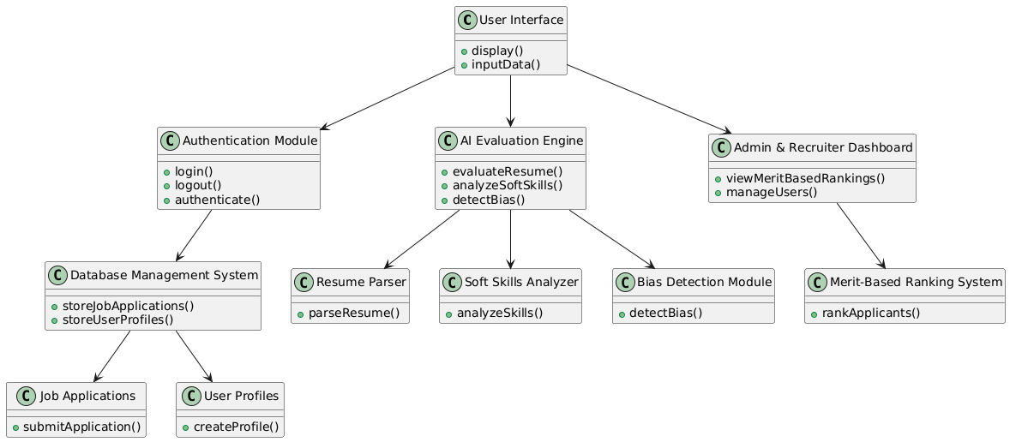

Fig 5.1: Class Diagram

## USE CASE DIAGRAM:

When modeling a system, it is crucial to focus on capturing its dynamic behaviour which refers to how the system behaves when it is running or actively functioning. To elaborate, dynamic behavior refers to the system's activities, interactions, and state changes during operation. Use case diagrams play a key role in eliciting requirements for a system, including both internal and external factors that influence the system. These requirements are typically related to the design phase of the system. When analysing a system to determine its functionalities, use cases are created, and actors both internal and external are identified.

To summarize, the main purposes of use case diagrams can be described as:

1. To gather the functional requirements of a system.
2. To obtain an external perspective of how the system interacts with its environment.
3. To identify the external and internal elements that impact the system's behavior and performance.

In essence, use case diagrams help in understanding the interactions, behaviors, and requirements of the system from a high-level viewpoint, providing valuable insights for the design and development phases.

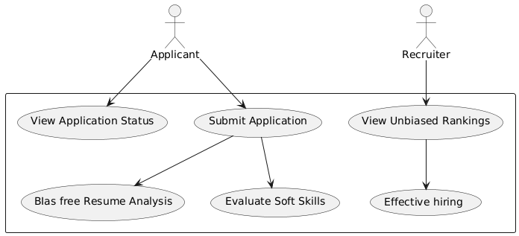

Fig 5.2: Use Case Diagram

## ACTIVITY DIAGRAM

The activity diagram is another essential diagram in UML used to represent the dynamic behavior of a system. Essentially, the activity diagram functions as a flowchart, illustrating how the system transitions from one activity to another. An activity in this context refers to an operation or task that the system performs.

The key purposes of an activity diagram can be outlined as:

* + - * Represent the flow of activities within the system.
      * Depict the sequence in which activities occur, from one step to the next.
      * Illustrate parallel, conditional, and concurrent flows, showing how different activities can happen simultaneously or branch off based on conditions.

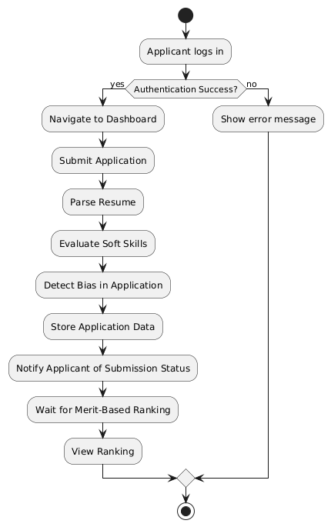

Fig 5.3: Activity Diagram

## SEQUENCE DIAGRAM

Sequence diagrams are used to represent interactions between classes or objects in terms of message exchanges over time. Often referred to as event diagrams, sequence diagrams are highly effective in visualizing and validating various runtime scenarios. They help in understanding how the system will behave during execution and can be instrumental in uncovering the responsibilities that a class should assume when designing a new system.

The primary purposes of sequence diagrams can be summarized as:

* + - * Visualize the interaction flow between objects or classes over time.
      * Validate different runtime scenarios, illustrating how the system components collaborate in real-time.
      * Identify the responsibilities of each class or object involved in the interaction during system design.

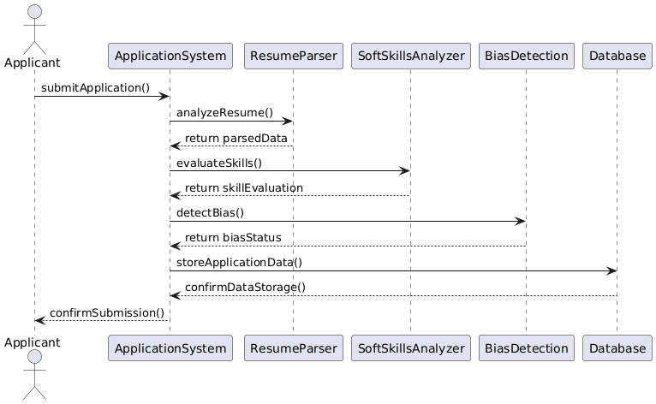

Fig 5.4: Sequence Diagram

## STATE CHART DIAGRAM

Statechart diagrams, also known as state machine diagrams, are used to describe the dynamic behavior of an object in response to different events or stimuli. They show how an object transitions from one state to another based on internal or external events. These diagrams are particularly useful for modeling the lifecycle of an object or an entity, tracking its state changes and how it reacts to different conditions.

The key purposes of statechart diagrams can be summarized as:

* + - * Model the lifecycle of an object, showing how it transitions through various states.
      * Represent state transitions based on events, detailing how the object responds to external or internal stimuli.
      * 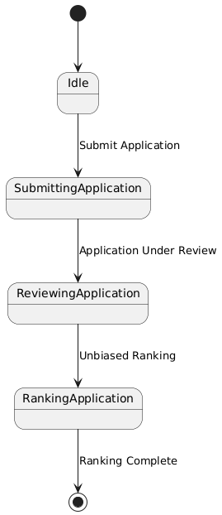

Fig 5.5: State Chart Diagram

## OBJECT DIAGRAM

An Object Diagram can be referred to as a screenshot of the instances in a system and the relationship that exists between them. Object diagrams are a crucial aspect of UML, providing a snapshot of the instances in a system at a particular moment. They help in visualizing the relationships between objects. An object diagram in UML is useful because it provides a clear and visual representation of specific instances of classes and their relationships at a particular point in time, aiding in understanding and communicating the structure and interactions within a system. In other words, “An object diagram in the Unified Modeling Language (UML), is a diagram that shows a complete or partial view of the structure of a modeled system at a specific time.

The use of object diagrams is limited, mainly to show examples of data structures. During the analysis phase of a project, you might create a class diagram to describe the structure of a system and then create a set of object diagrams as test cases to verify the accuracy and completeness of the class diagram.recognition, image classifications which appears to be the complex method.

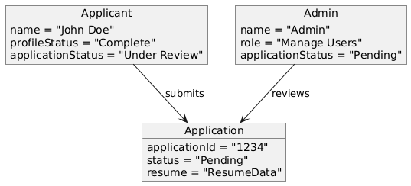

Fig 5.6: Object diagram

## DEPLOYMENT DIAGRAM

A UML deployment diagram is a diagram that shows the configuration of run time processing nodes and the components that live on them. Deployment diagrams is a kind of structure diagram used in modeling the physical aspects of an object-oriented system. They are often be used to model the static deployment view of a system (topology of the hardware).

* + - * They show the structure of the run-time system
      * They capture the hardware that will be used to implement the system and the links between different items of hardware.
      * They model physical hardware elements and the communication paths between them
      * They can be used to plan the architecture of a system.
      * They are also useful for Document the deployment of software components or nodes.

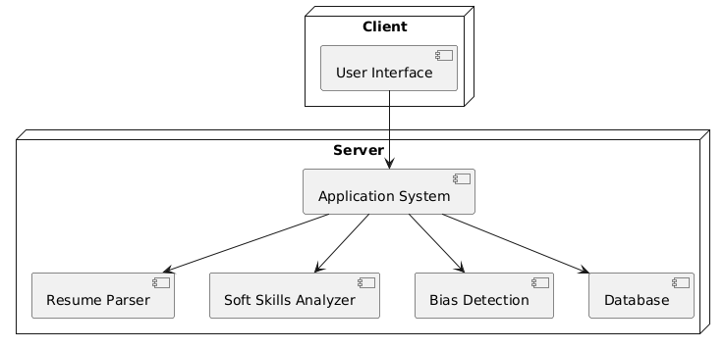

Fig 5.7: Deployment diagram

## COMPONENT DIAGRAM

UML Component diagrams are used in modeling the physical aspects of object-oriented systems that are used for visualizing, specifying, and documenting component-based systems and also for constructing executable systems through forward and reverse engineering. Component diagrams are essentially class diagrams that focus on a system's components that often used to model the static implementation view of a system.

* + - * It portrays the components of a system at the runtime.
      * It is helpful in testing a system.
      * It envisions the links between several connections.

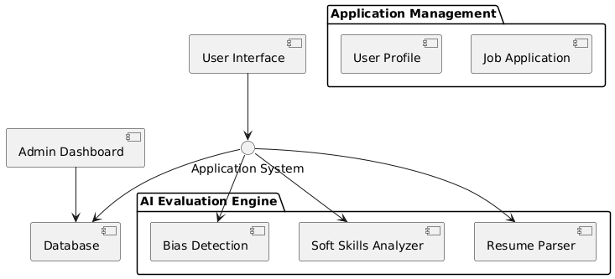

Fig 5.8: Component diagram

## COLLABORATION DIAGRAM

Collaboration diagrams (known as Communication Diagram in UML 2.x) are used to show how objects interact to perform the behavior of a particular use case, or a part of a use case. Along with sequence diagrams, collaboration are used by designers to define and clarify the roles of the objects that perform a particular flow of events of a use case. They are the primary source of information used to determining class responsibilities and interfaces.

It mainly puts emphasis on the structural aspect of an interaction diagram, i.e., how lifelines are connected.

* + - * The syntax of a collaboration diagram is similar to the sequence diagram; just the difference is that the lifeline does not consist of tails.
      * The messages transmitted over sequencing is represented by numbering each individual message.
      * The collaboration diagram is semantically weak in comparison to the sequence diagram.

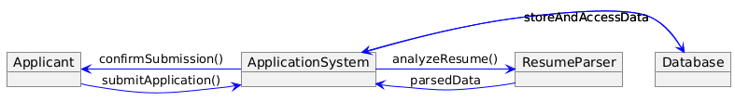

Fig 5.9: Collaboration diagram

# 5.3 ALGORITHM

**Input Layer:**

1. **User Login**:
   * **Input**: User credentials (username, password).
   * **Process**: Authenticate user via the authentication module.
   * **Output**: User dashboard or error message (authentication failure).
2. **Job Application Submission**:
   * **Input**: Applicant’s personal details, resume file.
   * **Process**: Applicant submits the application through the User Interface.
   * **Output**: A confirmation message indicating the submission status.

**Processing Layer:**

1. **Resume Parsing** (Using ResumeParser):
   * **Input**: Resume file (PDF/Word).
   * **Process**:
     + Extract key details such as name, contact information, education, work experience, and skills from the resume.
     + Use Natural Language Processing (NLP) techniques to structure the data.
   * **Output**: Structured data representing applicant's details and skills.
2. **Soft Skills Evaluation** (Using SoftSkillsAnalyzer):
   * **Input**: Applicant's personal details, application data, and any responses in forms or interview stages.
   * **Process**:
     + Analyze the soft skills based on pre-set criteria (such as communication skills, teamwork, leadership, etc.).
     + Evaluate responses (if any) from behavioral questions or past job experience.
   * **Output**: Soft skills evaluation score, indicating strengths and weaknesses in key soft skill areas.
3. **Bias Detection** (Using BiasDetectionModule):
   * **Input**: Application data (resume, personal details, soft skills).
   * **Process**:
     + Detect any biases related to gender, age, ethnicity, or other unfair preferences based on the analysis of historical hiring data.
     + Use AI/ML algorithms to ensure fairness in evaluating applicants.
   * **Output**: Bias detection report (flagging any potential bias in the evaluation process).
4. **Merit-Based Ranking and Recommendation** (Using MeritRankingSystem):
   * **Input**: Resume data, soft skills score, bias detection report.
   * **Process**:
     + Rank applicants based on the quality and relevance of their resumes, along with the evaluation of soft skills.
     + Ensure that bias has been addressed before final ranking.
   * **Output**: Final merit-based ranking of applicants.

**Control Layer:**

1. **Threading**:
   * **Input**: Multiple concurrent tasks such as resume parsing, soft skills evaluation, and bias detection.
   * **Process**:
     + Utilize threading to handle tasks concurrently, ensuring that the system remains responsive and does not block while one task is being processed.
     + Different tasks (resume parsing, soft skills analysis, and bias detection) are handled by separate threads.
   * **Output**: Smooth operation of the application system with no delays during multiple task processing.

**Complete Algorithm Workflow:**

1. **User Login**:
   * The user logs in using their credentials. If successful, the system proceeds to the applicant dashboard.
2. **Job Application Submission**:
   * The applicant submits their application with personal details and resume. The system confirms receipt.
3. **Resume Parsing**:
   * The system processes the resume and extracts structured data such as skills, experience, and education.
4. **Soft Skills Evaluation**:
   * The system evaluates the applicant's soft skills (if applicable), such as communication, leadership, etc., using predefined criteria.
5. **Bias Detection**:
   * The system analyzes the applicant's data for any potential biases. If bias is detected, the system flags the data for review.
6. **Merit-Based Ranking**:
   * Based on the parsed data, soft skills evaluation, and bias-free score, the system generates a merit-based ranking of applicants.
7. **Recruiter Dashboard**:
   * The recruiter logs into the system, views the ranking, and proceeds to review applications for hiring.
8. **Final Recommendation**:
   * The system presents the final rankings to the recruiter, including any recommended actions (e.g., top candidates to contact).

# CHAPTER 6

# REFERENCES

[1] Smith, J., & Brown, L. (2020). Bias in Hiring: Addressing Discrimination through AI. *Journal of AI Ethics and Recruitment*, 12(3), 45-60.

[2] Johnson, M., & Lee, C. (2021). AI Ethics in Recruitment: Ensuring Fair Candidate Evaluation. *International Conference on Machine Learning Applications*, 18(2), 101-115.

[3] Patel, R., & Gupta, S. (2019). Soft Skills Assessment Using NLP in Hiring Processes. *Computational Linguistics and AI Review*, 27(4), 87-102.

[4] Williams, T., & Zhang, Y. (2022). Unbiased Candidate Ranking in AI-Powered Hiring Systems. *IEEE Transactions on Human-Centric Computing*, 30(1), 220-235.